Set A

- A) Using javap, view the methods of the following classes from the lang package: java.lang.Object , java.lang.String and java.util.Scanner. and also Compile sample program 8. Type the following command and view the bytecodes. javap -c MyClass
- This program is not going to ave any code, just commands(for output)

b)
- Write a program to calculate perimeter and area of rectangle.
- (hint : area = length * breadth , perimeter=2*(length+breadth))

import java.util.Scanner;
public class Rectangle
{
public static void main(String[] args)
{
Scanner sc = new Scanner(System.in);

System.out.println("Enter Length of Rectangle : ");
int length = sc.nextInt();

System.out.println("Enter breadth of Rectangle : ");
int breadth = sc.nextInt();

int area = length * breadth;
System.out.println("Area of Reactangle : " + area);

int Perimeter = 2 * (length + breadth);
System.out.println("Perimeter of Reactangle : " + Perimeter);

sc.close();
}
}
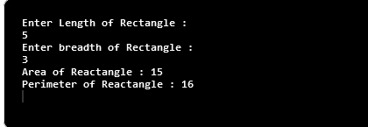
Output:

  - c) Write a menu driven program to perform the following operations
  - i. Calculate the volume of cylinder. (hint : Volume: π × r² × h)
  - ii. Find the factorial of given number.
  - iii. Check the number is Armstrong or not.
  - iv. Exit

import java.util.Scanner;

public class NumericalsMenu {
public static void main(String[] args) {

Scanner sc = new Scanner(System.in);

System.out.println("\n1.Volume of Cylinder. \n2.Factorial of Number. \n3.Armstrong Number. \n4.Exit");
System.out.println("Enter Your Choice : ");
int choice = sc.nextInt();
switch (choice) {
case 1:
System.out.println("Enter Radius:");
Float r = sc.nextFloat();
System.out.println("Enter Height:");
Float h = sc.nextFloat();
double Volume = Math.PI * r * r * h;
System.out.printf("Volume of Cylinder: %f" ,Volume);
break;
case 2:
System.out.println("Enter Number for Finding Factorial : ");
int num = sc.nextInt();
long fact = 1;
for (int i = 1; i <= num; ++i) {
fact = fact * i;
}
System.out.printf("Factorial of %d = %d\n", num, fact);
break;
case 3:
System.out.println("Enter Number for Finding Armstrong Number : ");
int n = sc.nextInt();
int leng = 0;
int t1 = n;
while (t1 != 0) {
t1 = t1 / 10;
leng = leng + 1;
}
int t2 = n;
int arm = 0;
int rem;
while (t2 != 0) {
int mult = 1;
rem = t2 % 10;
for (int i = 1; i <= leng; i++) {
mult = mult * rem;
}
arm = arm + mult;
t2 = t2 / 10;
}
if (arm == n) {
System.out.println("The given number is armstrong..!");
} else {
System.out.println("The given number is not armstrong..!");
}
break;
case 4:
System.exit(0);
default:
break;
}
sc.close();
}
}
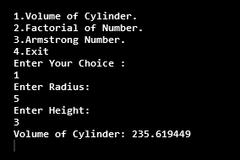
Output:-

Case1:

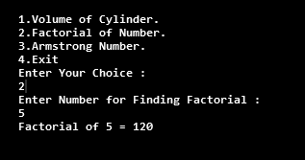
Case 2:

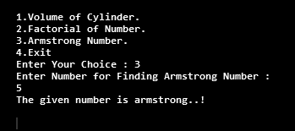
Case 3:

- d) Write a program to accept the array element and display in reverse order.

import java.util.Scanner;
public class ReverseArray {
public static void main(String[] args) {

Scanner sc = new Scanner(System.in);

System.out.println("Enter size of Array :");
int n = sc.nextInt();

int arr[] = new int[n];
System.out.println("Enter Elements in Array");
for (int i = 0; i < n; i++) {
arr[i] = sc.nextInt();
}
System.out.println("Array elements:");
for (int i = 0; i < n; i++) {
System.out.print(arr[i] + " ");
}
System.out.println("\nArray elements in Reverse Order :");
for (int i = n - 1; i >= 0; i--) {
System.out.print(arr[i] + " ");
}
sc.close();
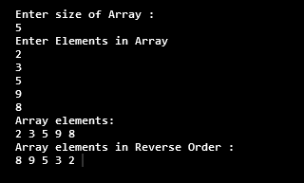
}
}
Output:-

Set B
- a) Write a java program to display the system date and time in various formats shown below:
Current date is : 31/08/2021 Current date is : 08-31-2021
Current date is : Tuesday August 31 2021
Current date and time is : Fri August 31 15:25:59 IST 2021 Current date and time is : 31/08/21 15:25:59 PM +0530 Current time is : 15:25:59
Current week of year is : 35 Current week of month : 5 Current day of the year is : 243
- Note: Use java.util.Date and java.text.SimpleDateFormat class

import java.text.SimpleDateFormat;
import java.util.Date;

public class DateFormatter {
public static void main(String[] args) {

Date date = new Date();
SimpleDateFormat sdf = new SimpleDateFormat("dd/MM/yyyy");
String Str = sdf.format(date);
System.out.println("Current date is: " + Str);

sdf = new SimpleDateFormat("MM-dd-yyyy");
Str = sdf.format(date);
System.out.println("Current date is: " + Str);

sdf = new SimpleDateFormat("EEEE MMMM dd yyyy");
Str = sdf.format(date);
System.out.println("Current date is: " + Str);

sdf = new SimpleDateFormat("E MMMM dd HH:mm:ss z yyyy");
Str = sdf.format(date);
System.out.println("Current date and time is: " + Str);

sdf = new SimpleDateFormat("dd/MM/yy HH:mm:ss a Z");
Str = sdf.format(date);
System.out.println("Current date and time is: " + Str);

sdf = new SimpleDateFormat("hh:mm:ss");
Str = sdf.format(date);
System.out.println("Current time is: " + Str);

sdf = new SimpleDateFormat("w");
Str = sdf.format(date);
System.out.println("Current week of year is: " + Str);

sdf = new SimpleDateFormat("W");
Str = sdf.format(date);
System.out.println("Current week of the month is: " + Str);

sdf = new SimpleDateFormat("D");
Str = sdf.format(date);
System.out.println("Current day of the year: " + Str);
}
}
Output:-
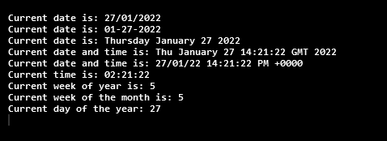

- b) Define a class MyNumber having one private int data member. Write a default constructor to initialize it to 0 and another constructor to initialize it to a value (Use this). Write methods isNegative, isPositive, isZero, isOdd, isEven. Create an object in main. Use command line arguments to pass a value to the object
(Hint : convert string argument to integer) and perform the above tests. Provide javadoc comments for all constructors and methods and generate the html help file.

public class MyNumber {
private int x;

public MyNumber() {
x = 0;
}
public MyNumber(int x) {
this.x = x;
}
public boolean isNegative() {
if (x < 0)
return true;
else
return false;
}

public boolean isPositive() {
if (x > 0)
return true;
else
return false;
}

public boolean isZero() {
if (x == 0)
return true;
else
return false;
}

public boolean isOdd() {
if (x % 2 != 0)
return true;
else
return false;
}

public boolean isEven() {
if (x % 2 == 0)
return true;
else
return false;
}

public static void main(String[] args){
int x = Integer.parseInt(args[0]);
MyNumber m = new MyNumber(x);
if (m.isNegative()) {
System.out.println("Number is Negative");
}
if (m.isPositive()) {
System.out.println("Number is Positive");
}
if (m.isEven()) {
System.out.println("Number is Even");
}
if (m.isOdd()) {
System.out.println("Number is Odd");
}
if (m.isZero()) {
System.out.println("Number is Zero");
}
}
}

  - c) Write a menu driven program to perform the following operations on multidimensional array ie matrix : i. Addition
  - ii. Multiplication
  - iii. Transpose of any matrix.
  - iv. Exit

import java.util.Scanner;

public class MenuMatrix {
// to calculate Addition of matrix
public void addition() {
Scanner sc = new Scanner(System.in);
System.out.println("Enter size of row and column: ");
int r = sc.nextInt();
int c = sc.nextInt();

int[][] m1 = new int[r][c];
int[][] m2 = new int[r][c];

System.out.println("\nEnter values of matrix M1:\n");
for (int i = 0; i < r; i++) {
for (int j = 0; j < c; j++) {
System.out.printf("Enter element at index %d and %d :", i, j);
m1[i][j] = sc.nextInt();
}
}
System.out.println("\nEnter values of matrix M2:\n");
for (int i = 0; i < r; i++) {
for (int j = 0; j < c; j++) {
System.out.printf("Enter element at index %d and %d :", i, j);
m2[i][j] = sc.nextInt();
}
}
System.out.println("\nSum of M1 and M2:");
int[][] sum = new int[r][c];
for (int i = 0; i < r; i++) {
for (int j = 0; j < c; j++) {
sum[i][j] = m1[i][j] + m2[i][j];
}
}
for (int i = 0; i < r; i++) {
for (int j = 0; j < c; j++) {
System.out.print(sum[i][j] + " ");
}
System.out.println();
}
sc.close();

}// Addition

// To Multiplicate Matrices

public void multiplication() {

Scanner sc = new Scanner(System.in);
System.out.println("Enter size of row and column: ");
int r = sc.nextInt();
int c = sc.nextInt();

int[][] m1 = new int[r][c];
int[][] m2 = new int[r][c];
System.out.println("\nEnter values of matrix M1:\n");
for (int i = 0; i < r; i++) {
for (int j = 0; j < c; j++) {
System.out.printf("Enter element at index %d and %d :", i, j);
m1[i][j] = sc.nextInt();
}
}
System.out.println("\nEnter values of matrix M2:\n");
for (int i = 0; i < r; i++) {
for (int j = 0; j < c; j++) {
System.out.printf("Enter element at index %d and %d :", i, j);
m2[i][j] = sc.nextInt();
}
}

System.out.println("\nMultiplication of M1 and M2:\n");
int[][] mul = new int[r][c];
for (int i = 0; i < r; i++) {
for (int j = 0; j < c; j++) {
for (int k = 0; k < c; k++) {
mul[i][j] = mul[i][j] + m1[i][k] * m2[k][j];
}
}
}
for (int i = 0; i < r; i++) {
for (int j = 0; j < c; j++) {
System.out.print(mul[i][j] + " ");
}
System.out.println();
}
sc.close();
}// Multiplication

// Transpose of Matrix
public void transpose() {

Scanner sc = new Scanner(System.in);
System.out.println("Enter size of row and column: ");
int r = sc.nextInt();
int c = sc.nextInt();

int[][] m = new int[r][c];
System.out.println("Enter values of Matrix:\n");
for (int i = 0; i < r; i++) {
for (int j = 0; j < c; j++) {
System.out.printf("Enter element at index %d and %d :", i, j);
m[i][j] = sc.nextInt();
}
}
System.out.println("\nEntered Matrix...\n");
for (int i = 0; i < r; i++) {
for (int j = 0; j < c; j++) {
System.out.print(m[i][j] + " ");
}
System.out.println();
}
System.out.println("\nTranspose Matrix...\n");
for (int i = 0; i < r; i++) {
for (int j = 0; j < c; j++) {
System.out.print(m[j][i] + " ");
}
System.out.println();
}
sc.close();
}// Transpose

public static void main(String[] args) {
MenuMatrix m = new MenuMatrix();
Scanner sc = new Scanner(System.in);

System.out.println("\n1.Addition of Matrix. \n2.Multiplication of Matrix. \n3.Transpose of Matrix. \n4.Exit");
System.out.println("Enter Your Choice : ");
int choice = sc.nextInt();
switch (choice) {
case 1:
m.addition();
break;
case 2:
m.multiplication();
break;
case 3:
m.transpose();
break;
}
sc.close();
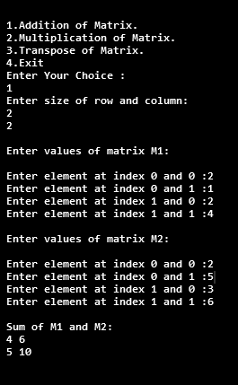
}
Output:-

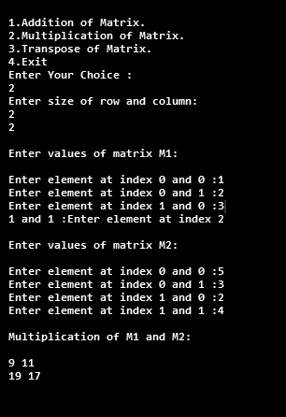
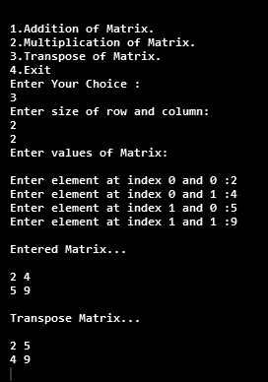

Set C
- a) Write a program to accept n names of country and display them in descending order.
import java.util.*;

public class countrysort {
public static void main(String[] args) {
Scanner sc = new Scanner(System.in);
System.out.println("Enter total no of Countries: ");
int n = sc.nextInt();
String country[] = new String[n];
sc.nextLine();
for (int i = 0; i < n; i++) {
System.out.println("Enter country no :" + (i + 1));
country[i] = sc.nextLine();
}
System.out.println("Country names without Sorting:");
for (String ele : country) {
System.out.println("" + ele);
}
String temp;
for (int i = 0; i < n; i++) {
for (int j = i + 1; j < n; j++) {
if (country[i].compareTo(country[j]) < 0) {
temp = country[i];
country[i] = country[j];
country[j] = temp;
}
}
}
System.out.println("Countries in Descending order:");
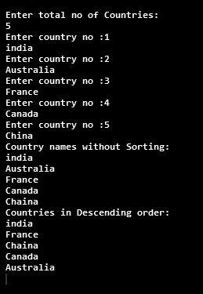
for (String ele : country) {
System.out.println("" + ele);
}
sc.close();
}
}
Output:-

  - b) Write a menu driven program to perform the following operations on 2D array: i. Sum of diagonal elements
  - ii. Sum of upper diagonal elements
  - iii. Sum of lower diagonal elements
  - iv. Exit

import java.util.*;
public class DiagonalMenu {
public static void main(String[] args) {
Scanner sc = new Scanner(System.in);
System.out.println("Enter size of row and column: ");
int n = sc.nextInt();
int sum = 0;
int[][] m = new int[n][n];
System.out.println("\nEnter values of matrix :\n");
for (int i = 0; i < n; i++) {
for (int j = 0; j < n; j++) {
m[i][j] = sc.nextInt();
}
}
System.out.println("\nEntered Matrix...\n");
for (int i = 0; i < n; i++) {
for (int j = 0; j < n; j++) {
System.out.print(m[i][j] + " ");
}
System.out.println();
}
do {
System.out.println("\nMatrix Operations\n");
System.out.println("\n1.Sum of Diagonal Elements.");
System.out.println("\n2.Sum of Upper Diagonal Elements.");
System.out.println("\n3.Sum of Lower Diagonal Elements.");
System.out.println("\n4.Exit");
System.out.println("Enter Your Choice :");
int ch = sc.nextInt();
switch (ch) {
case 1:
sum = 0;
for (int i = 0; i < m.length; i++) {
for (int j = 0; j < m.length; j++) {
if (i==j) {
sum = sum+m[i][j];
}
}
}
System.out.println("\nAddition of Diagonal Elements:"+sum);
break;
case 2:
sum = 0;
for (int i = 0; i < m.length; i++) {
for (int j = 0; j < m.length; j++) {
if (j>i) {
sum = sum+m[i][j];
}
}
}
System.out.println("\nAddition of Upper Diagonal Elements:"+sum);
break;
case 3:
sum = 0;
for (int i = 0; i < m.length; i++) {
for (int j = 0; j < m.length; j++) {
if (i>j) {
sum = sum+m[i][j];
}
}
}
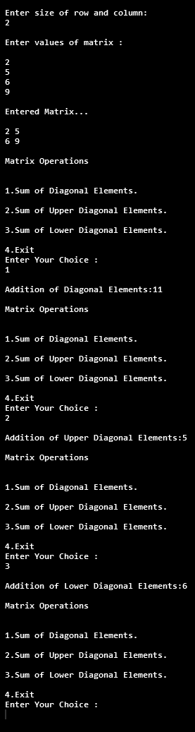
System.out.println("\nAddition of Lower Diagonal Elements:"+sum);
break;
case 4:
System.exit(0);
default:
break;
}
} while (true);

}
}
Output:-
.

- c) Write a program to display the 1 to 15 tables.

( 1 * 1 = 1 | 2 * 1 = 2 |  | ……. |  | 15 * 1 = 15
1 * 2 = 2 |  | 2 * 2 = 4 |  | 15 * 2 = 30
1 * 3 = 3  … |  | 2 * 3 = 6  … |  | 15 * 3 = 45  …..

public class table {
public static void main(String[] args) {
for (int i = 1; i <= 15; i++) {
System.out.println("Table of "+(i)+" number:\n");
for (int j = 1; j <= 10; j++) {

System.out.println(i + "*" + j + "=" +i*j);
}
System.out.println("----------------------");
}
}
}

